Genetic Algorithms
Section #6
Constraint Satisfaction Problem (CSP)
It is a problem which has variables, values and constraints, which you are asked to find solution based on all constraints.

Optimization Problem
We search for the best possible solution.
Search Problem
We search for a correct solution only

Role of Genetic Algorithms
Instead of using traditional search methods:
- We use a population of solutions
- We generate multiple candidate solutions
- We evaluate them based on:
  - Solution quality
  - Degree of constraint satisfaction
N-QUEEN Problem
Originally known as the eight-queen puzzle, the classic N-Queens problem originated from the game of chess, and the 8x8 chessboard was its early playground. The task was to place eight chess queens on the board without any two of them threatening each other. In other words, no two queens can share the same row, same column, or same diagonal. The N-Queens problem is similar, using an N×N chessboard and N chess queens.

The problem is known to have a solution for any natural number, n, except for the cases of n=2 and n=3. For the original eight-queen case, there are 92 solutions, or 12 unique solutions if we consider symmetrical solutions to be identical. One of the solutions is as follows:

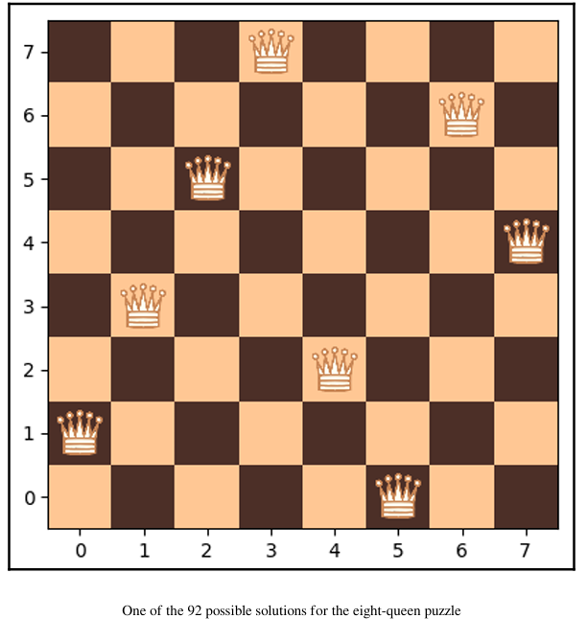
By applying combinatorics, the count of all possible ways to place eight pieces on the 8×8 board yields 4,426,165,368 combinations. However, if we can create our candidate solutions in a way that ensures that no two queens will be placed on the same row or the same column, the number of possible combinations is dramatically reduced to 8! (factorial of 8), which amounts to 40,320.
Intuition : Constraint-aware encoding dramatically reduces the search space, making genetic algorithms much faster and more effective.

